NamaPeserta : Giovanni Christian Antonio

Kode Peserta : FSDO002ONL004

Tugas : Assigment 2

Deskripsi: Membuat Database

SQL:

|  |
| --- |
| create database db_bank; |

Deskripsi: Membuat table offices

SQL:

|  |
| --- |
| create table product(  productCode varchar(10) PRIMARY KEY,  productName varchar(50) not null,  productLine varchar(10) not null,  productScale varchar(20) ,  productVendor varchar(50) not null,  productDescription varchar(100),  quantityInStock int not null,  buyPrice int not null,  MSRP int not null,  foreign key (productLine) references productlines(productLine)  ); |

Deskripsi: Membuat table employees

SQL:

|  |
| --- |
| create table employees(  employeeNumber int PRIMARY KEY,  lastName varchar(50) not null,  firstName varchar(50) not null,  extension varchar(50) not null,  email varchar(50),  officeCode int not null,  reportsTo int,  jobTitle varchar(50)  foreign key (reportsTo) references employees(employeeNumber),  foreign key (officeCode) references offices(officeCode)  ); |

Deskripsi: Membuat table customers

SQL:

|  |
| --- |
| create table customers(  customerNumber int PRIMARY KEY,  customerName varchar(50) not null,  contactLastName varchar(50) not null,  contactFirstName varchar(50) not null,  phone int not null,  addressLine1 varchar(100)not null,  addressLine2 varchar(100) null,  city varchar(50)not null,  state varchar(50)not null,  postalCode int not null,  country varchar(50)not null,  salesRepEmployeeNumber int not null,  creditLimit int not null  foreign key (salesRepEmployeeNumber) references employees(employeeNumber)  ); |

Deskripsi: Membuat table productlines

SQL:

|  |
| --- |
| create table productlines(  productLine varchar(10) PRIMARY KEY,  textDescription varchar(100) not null,  htmlDescription varchar(100) not null,  pimage varbinary  ); |

Deskripsi: Membuat table product

SQL:

|  |
| --- |
| create table product(  productCode varchar(10) PRIMARY KEY,  productName varchar(50) not null,  productLine varchar(10) not null,  productScale varchar(20) ,  productVendor varchar(50) not null,  productDescription varchar(100),  quantityInStock int not null,  buyPrice int not null,  MSRP int not null,  foreign key (productLine) references productlines(productLine)  ); |

Deskripsi: Membuat table order

SQL:

|  |
| --- |
| create table orders(  orderNumber varchar(10) PRIMARY KEY,  orderData varchar(100) not null,  requiredDate date ,  shippedDate date,  status varchar(20) not null,  comments varchar(100),  customerNumber int not null,  foreign key (customerNumber) references customers(customerNumber)  ); |

Deskripsi: Membuat table orderdetails

SQL:

|  |
| --- |
| create table ordersdetails(  orderNumber varchar(10) not null,  productCode varchar(10) not null,  quantityOrdered int not null,  priceEach int not null,  orderLineNumber int not null,  foreign key (orderNumber) references orders(orderNumber),  foreign key (productCode) references product(productCode)  ); |

Deskripsi: Membuat table payment

SQL:

|  |
| --- |
| create table payment(  customerNumber int not null,  checkNumber varchar(10) PRIMARY KEY,  paymentDate date not null,  amount int not null  foreign key (customerNumber) references customers(customerNumber)  ); |

Deskripsi: Memasukan data productline

SQL:

|  |
| --- |
| insert into productlines values  ('PL0001','Daging','Makanan enak',null),  ('PL0002','Minuman','Minuman enak',null),  ('PL0003','Snack','Snack enak',null),  ('PL0004','Puding','Puding enak',null),  ('PL0005','Es krim','Es krim enak',null),  ('PL0006','Nasi','Nasi enak',null),  ('PL0007','Sayuran','Sayuran enak',null),  ('PL0008','Kopi','Kopi enak',null),  ('PL0009','Teh','Teh enak',null),  ('PL0010','Gorengan','Gorengan enak',null)  ; |

Screenshoot hasil:

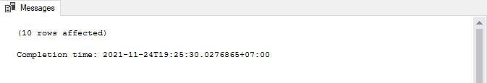

Deskripsi: Memasukan data Product

SQL:

|  |
| --- |
| insert into product values  ('P00001','Bebek Goreng', 'PL0001','', 'ABC','Bebek Goreng', 10, 20000, 18000),  ('P00002','Teh olong', 'PL0009','', 'teh','Teh olong', 100, 3000, 3000),  ('P00003','Puding Vanilla', 'PL0004','', 'puding indonesia','Puding Vanilla', 50, 5000, 4000),  ('P00004','Nasi Putih', 'PL0006','', 'BAC','Nasi Putih', 50, 2000, 2000),  ('P00005','Steak Sirloin', 'PL0001','', 'ABC','Steak Sirloin', 30, 50000, 56000),  ('P00006','Dadar Jagung', 'PL0001','', 'Warung','Dadar Jagung', 20, 2000, 1500),  ('P00007','Es Krim Coklat', 'PL0005','', 'Krim','Es Krim Coklat', 5, 5000, 6000),  ('P00008','Es Krim Vannila', 'PL0005','', 'Krim','Es Krim Vannila', 70, 3000, 3000),  ('P00009','Kopi Arabika', 'PL0008','', 'kopiiii','Kopi Arabika', 100, 5000, 4800),  ('P00010','Puding Coklat', 'PL0004','', 'puding indonesia','Puding Coklat', 180, 5000, 4000); |

Screenshoot hasil:

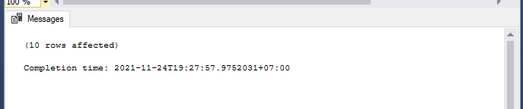

Deskripsi: Menambahkan data offices

SQL:

|  |
| --- |
| insert into offices values  (0001,'Surabaya',123456789, 'Surabaya Barat', 'Indonesia','Jawa Timur',60155,'Barat'),  (0002,'Surabaya',234567891, 'Surabaya Timur', 'Indonesia','Jawa Timur',60150,'Timur'),  (0003,'Jakarta',345678912, 'Jakarta Barat', 'Indonesia','Jakarta',62151,'Barat'),  (0004,'Jakarta',456789123, 'Jakarta Timur', 'Indonesia','Jakarta',62152,'Timur'),  (0005,'Bandung',567891234, 'Bandung Barat', 'Indonesia','Jawa Barat',60111,'Barat'),  (0006,'Bandung',678912345, 'Bandung Timur', 'Indonesia','Jawa Barat',60110,'Timur'),  (0007,'Solo',789123456, 'Solo', 'Indonesia','Jawa Tengah',65456,''),  (0008,'Madiun',891234567, 'Madiun', 'Indonesia','Jawa Timur',66512,''),  (0009,'Banyuwangi',912345678, 'Banyuwangi', 'Indonesia','Jawa Timur',67123,''),  (0010,'Probolinggo',234567899, 'Probolinggo', 'Indonesia','Jawa Timur',69125,''); |

Screenshoot hasil:

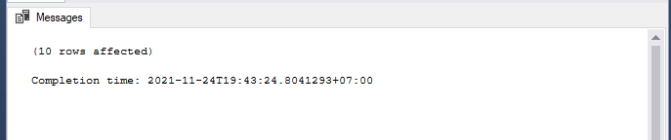

Deskripsi:Menambah Data employees

SQL:

|  |
| --- |
| insert into employees values  (0001,'Suryatmi', 'Mila','','mila@gmail.com',0010,null,'Menerima report dari sales'),  (0002,'Kuswoyo', 'Hasim','','Hasim@gmail.com',0010,0001,'Sales'),  (0003,'Anggraini', 'Ami','','Ami@gmail.com',0010,0001,'Sales'),  (0004,'Hidayanto', 'Rosman','','Rosman@gmail.com',0001,null,'Menerima report dari sales'),  (0005,'Sitorus', 'Lukman','','Lukman@gmail.com',0002,null,'Menerima report dari sales'),  (0006,'Haryanti', 'Hafshah','','Hafshah@gmail.com',0001,0004,'sales'),  (0007,'Mangunsong', 'Waluyo','','Waluyo@gmail.com',0002,0005,'sales'),  (0008,'Namaga', 'Ifa','','Ifa@gmail.com',0003,0008,'Menerima report dari sales & Sales'),  (0009,'Widiastuti', 'Kania','','Kania@gmail.com',0005,0009,'Menerima report dari sales & Sales'),  (0010,'Pradipta', 'Bagus','','Bagus@gmail.com',0009,0010,'Menerima report dari sales & Sales'); |

Screenshoot hasil:

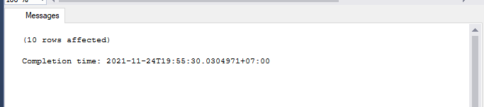

Deskripsi: Menambahkan Data customers

SQL:

|  |
| --- |
| insert into customers values  (000001,'Ira Purwanti','Purwanti','Ira', '987654321','Surabaya', null, 'Surabaya' , 'Timur', 60150, 'Indonesia', 0004, 50000 ),  (000002,'Digdaya Hardiansyah','Hardiansyah','Digdaya', '876543219','Jakarta', null, 'Jakarta' , 'Barat', 62151, 'Indonesia', 0008, 150000 ),  (000003,'Balijan Zulkarnain','Zulkarnain','Balijan', '765432198','Probolinggo', null, 'Probolinggo' , '', 69125, 'Indonesia', 0002, 20000 ),  (000004,'Hasta Natsir','Natsir','Hasta', '654321987','Surabaya', null, 'Surabaya' , 'Barat', 60155, 'Indonesia', 0006, 125000 ),  (000005,'Zamira Farida','Farida','Zamira', '543219876','Banyuwangi', null, 'Banyuwangi' , '', 67123, 'Indonesia', 0010, 55000 ),  (000006,'Akarsana Wasita','Wasita','Akarsana', '432198765','Jakarta', null, 'Jakarta' , 'Barat', 62151, 'Indonesia', 0008, 60000 ),  (000007,'Arsipatra Irawan','Irawan','Arsipatra', '321987654','Jakarta', null, 'Jakarta' , 'Barat', 62151, 'Indonesia', 0008, 150000 ),  (000008,'Keisha Agustina','Agustina','Keisha', '219876543','Probolinggo', null, 'Probolinggo' , '', 69125, 'Indonesia', 0002, 300000 ),  (000009,'Baktiadi Nababan','Nababan','Baktiadi', '198765432','Surabaya', null, 'Surabaya' , 'Timur', 60150, 'Indonesia', 0006, 500000 ),  (000010,'Cindy Wastuti','Wastuti','Cindy', '119876543','Surabaya', null, 'Surabaya' , 'Timur', 60150, 'Indonesia', 0008, 700000 ); |

Screenshoot hasil:

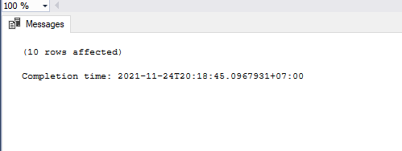

Deskripsi: Menambahkan Data payment

SQL:

|  |
| --- |
| insert into payment values  (000001,'CN000001', '2021-01-01', 150000),  (000002,'CN000002', '2021-03-29', 30000),  (000003,'CN000003', '2021-01-24', 500000),  (000004,'CN000004', '2021-11-21', 800000),  (000005,'CN000005', '2021-01-10', 90000),  (000006,'CN000006', '2021-02-05', 50000),  (000007,'CN000007', '2021-05-25', 10000),  (000008,'CN000008', '2021-06-21', 50000),  (000009,'CN000009', '2021-07-11', 1500000),  (000010,'CN000010', '2021-09-01', 200000); |

Screenshoot hasil:

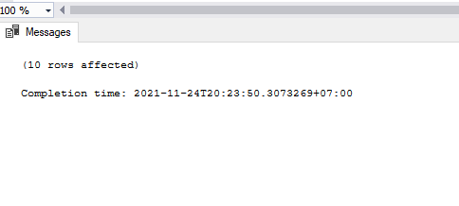

Deskripsi: Menambahkan Data Order

SQL:

|  |
| --- |
| insert into orders values  ('O00000001', '','2021-01-01','2021-01-01','Done','',000001),  ('O00000002', '','2021-04-15','2021-04-17','Done','',000002),  ('O00000003', '','2021-05-14','2021-05-16','Done','',000003),  ('O00000004', '','2021-06-26','2021-06-28','Done','',000004),  ('O00000005', '','2021-05-18','2021-05-20','Done','',000005),  ('O00000006', '','2021-11-01','2021-11-30','Pending','',000006),  ('O00000007', '','2021-11-01','2021-11-29','Pending','',000007),  ('O00000008', '','2021-11-01','2021-11-29','Pending','',000008),  ('O00000009', '','2021-11-01','2021-11-30','Pending','',000009),  ('O00000010', '','2021-11-01','2021-11-30','Pending','',000001); |

Screenshoot hasil:

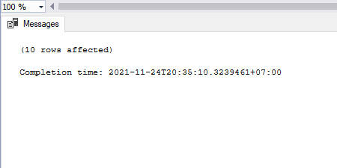

Deskripsi: Menambahkan Data detail order

SQL:

|  |
| --- |
| insert into ordersdetails values  ('O00000001', 'P00001',10,25000,1),  ('O00000002', 'P00002',10,5000,1),  ('O00000003', 'P00010',10,10000,1),  ('O00000004', 'P00010',16,10000,1),  ('O00000005', 'P00003',15,10000,1),  ('O00000006', 'P00009',20,8000,1),  ('O00000007', 'P00004',5,25000,1),  ('O00000008', 'P00005',3,80000,1),  ('O00000009', 'P00005',4,80000,1),  ('O00000010', 'P00005',5,80000,1); |

Screenshoot hasil:

